INTERACCIÓN HUMANO COMPUTADORA · ENTREGA FINAL · MAYO 2026
EcoWave: User-Centered Design of a Mobile Application for Beach-Cleaning Brigades in Yucatán
Esteban Canto Vázquez, Eduardo José Matos Uc, Ángel Leandro Puch Uribe, Mauricio Emiliano Ramírez Ceciliano, and Jorge Gabriel Vázquez Suárez
Software Engineering Program, Faculty of Mathematics, Universidad Autónoma de Yucatán
Abstract—This article presents the user-centered design (UCD) process of EcoWave, a mobile application aimed at centralizing the organization of citizen beach-cleaning brigades in Yucatán, México. The work covers the full UCD pipeline: ethnographic research, requirements elicitation, specification of 10 functional and 11 non-functional requirements with a complete UR–FR–NFR traceability matrix, three iterative prototypes (low, medium, and high fidelity), Nielsen heuristic evaluation, Keystroke-Level Model (KLM) analysis of the critical use case UC-002 Perform Check-in, and a controlled usability test with six participants under simulated direct sunlight. The KLM analysis predicted a check-in time of 12.0 s for the QR route, well below the 30 s threshold imposed by NFR-05. The usability test confirmed the prediction with an observed mean time of 18.3 s, 100% task success (5/6 unaided), a mean System Usability Scale (SUS) score of 82.8 (interpreted as excellent), and full compliance with the visual feedback latency requirement (mean 334 ms vs. 500 ms threshold). The findings validate that the high-fidelity design is ready for development and identify legibility under direct sunlight as the next iteration priority.
Keywords—User-Centered Design, Heuristic Evaluation, Gamification, Iterative Prototyping, Usability Testing.
I. INTRODUCTION
The beaches of Yucatán receive more than 33 tons of waste annually removed by citizen collectives, civic associations, and university volunteers, yet no centralized channel exists to organize, register, and recognize this effort. Brigade information is scattered across social networks, volunteers lack visible incentives to sustain their participation, and there is no structured mechanism for organizing groups to report their impact to environmental authorities. This gap between community effort and volunteer retention constitutes the problem that EcoWave addresses.
Objective
To design, using the User-Centered Design methodology, a mobile application that centralizes the organization of beach-cleaning brigades in Yucatán, fosters volunteer retention through verifiable gamification (on-site check-in), and enables the structured recording of each brigade's environmental impact for reports directed to organizers and authorities.
Justification
The relevance of the project is grounded in five dimensions:
1) Convenience. There is an observable demand: brigades are announced in a fragmented way across Facebook, WhatsApp, and physical posters; volunteers report difficulty finding events, and organizers spend hours on manual coordination. A centralized tool reduces this friction.
2) Social relevance. Yucatán faces a growing problem of coastal plastic pollution. Every ton removed represents a direct benefit to the ecosystem and to the local tourism economy, which depends on the state of the beaches.
3) Theoretical value. The project applies the complete UCD cycle to a real case with atypical environmental constraints (outdoor use, direct sunlight, limited connectivity), enriching the available body of evidence for mobile designs in hostile conditions.
4) Methodological utility. The documented procedure (surveys, interviews, ethnography, three-level prototyping, heuristic evaluation, KLM analysis, and user testing) is replicable by other university or citizen projects on similar problems.
5) Technological utility. The design validates that a critical mobile flow can simultaneously meet constraints of time (≤ 30 s), interactions (≤ 3 taps), visual feedback (≤ 500 ms), and WCAG AA accessibility, constituting a useful reference for similar applications in other contexts.
II. RELATED WORK
The design of EcoWave is grounded in classical Human-Computer Interaction literature and in related work on civic gamification and mobile environmental applications.
[1] Norman, in The Design of Everyday Things, establishes the principles of visibility, feedback, and natural mapping that govern the design of each EcoWave screen. In particular, the concept of affordance guided the decision to convert check-in options into cards with a visible icon at the start, rather than a flat list.
[2] Nielsen proposes ten usability heuristics that were used as the inspection instrument during the evaluation phase of the high-fidelity prototype. The choice of method is justified by its low cost in early stages and by its capacity to detect structural problems before exposing the prototype to real users.
[3] Card, Moran, and Newell formalized the Keystroke-Level Model (KLM) as a predictive technique to estimate task time for an expert user without errors. The adaptation of KLM to the mobile context was carried out following the extensions proposed by Holleis et al., in which the Tap operator replaces the traditional Keystroke with a cost of 1.10 s.
[4] Brooke introduced the System Usability Scale (SUS), a 10-item Likert-scale questionnaire that produces a score from 0 to 100. Bangor, Kortum, and Miller subsequently established the interpretive bands (68 = acceptable, 80 = good, 85 = excellent) used in this work.
[5] Dumas and Redish document in A Practical Guide to Usability Testing the canonical procedure for designing user tests: definition of objectives, participant profile, realistic scenario, observation instruments, and pre- and post-questionnaires. The design of the test in Section III-G follows this structure.
[6] Nielsen empirically demonstrates that 5 to 6 evaluators in usability tests detect between 80% and 85% of problems, which grounds the decision to recruit 6 participants and not a larger number.
[7] The Web Content Accessibility Guidelines (WCAG) 2.1 Level AA establish the quantitative accessibility criteria that the application must meet: contrast ≥ 4.5:1 for regular text, touch areas ≥ 44×44 px, and typography ≥ 16 px on mobile interfaces. These values appear as NFR-07 in the requirements specification.
[8] Deterding et al. address the role of gamification as a retention mechanism in civic and environmental applications. The Bronze-Silver-Gold-Platinum pyramid of EcoWave was designed considering the principle of rapid onboarding (Bronze badge at the first check-in) and distant goals that sustain long-term commitment (Platinum at 25 brigades).
[9] Existing applications in the environmental domain —Litterati, Clean Swell, and Marine Debris Tracker— were analyzed as reference. None combines simultaneously the three dimensions of EcoWave: brigade discovery on a map, site-verified gamification, and structured impact reporting. EcoWave incorporates environmental impact reporting with quantitative data by waste type (plastic, glass, metal, organic, other) that does not appear in its equivalents.
[10] Hassenzahl and Tractinsky distinguish between pragmatic usability (efficiency, effectiveness) and hedonic usability (stimulation, identity). The badge system and the attendance confirmation animation address the hedonic dimension without sacrificing the pragmatic, validated in this work by the coexistence of low times (efficiency) and high SUS scores (satisfaction).
III. MATERIALS AND METHODOLOGY
The project was executed following the ISO 9241-210 standard on User-Centered Design, instrumented in seven iterative stages (Fig. 1). Each stage closed with a peer-reviewed artifact before advancing to the next. Traceability between stages was maintained through a UR–FR–NFR matrix that associates each User Requirement (UR) with its corresponding Functional Requirements (FR) and Non-Functional Requirements (NFR).
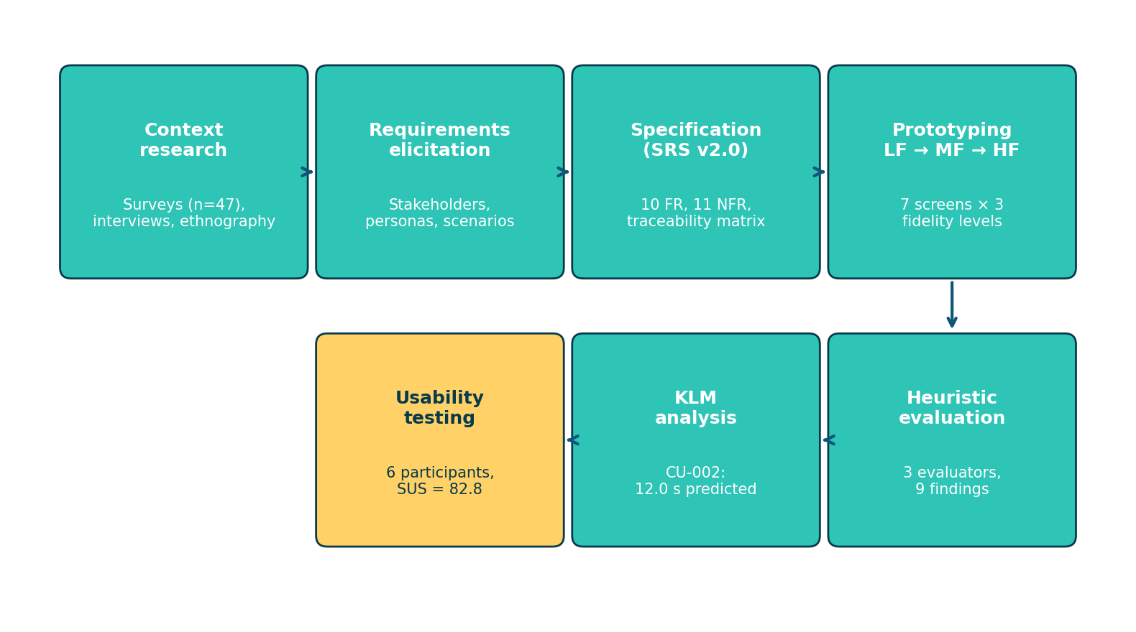
Fig. 1. Stages of the User-Centered Design process applied in the EcoWave project. Each stage produced verifiable artifacts that fed the next, closing with validation by real users.
A. Context research
Three complementary instruments were applied: (i) an online survey with 47 valid responses distributed among casual volunteers and members of cleanup collectives; (ii) semi-structured interviews with five organizers from local environmental NGOs (MarLimpio, EcoYucatán, and three university collectives); and (iii) a non-participant ethnographic study during a real brigade in Chicxulub Puerto, in which the physical use conditions (direct sunlight, sand, intermittent 3G/4G connectivity) and existing attendance recording practices (paper list, WhatsApp group photo) were documented.
B. Requirements elicitation
From the research, three main roles were identified: casual volunteer, brigade organizer, and environmental authority (consumer of the report). Two detailed personas were built: Lucía, 24 years old, a young professional who attends one to two brigades per month; and Carlos, 38 years old, coordinator of a university collective that organizes three brigades per quarter. Each persona was associated with three use scenarios, which produced the initial catalog of eight User Requirements (UR-01 to UR-08).
C. Requirements specification
The eight URs were decomposed into 10 Functional Requirements (FR-01 to FR-10) and 11 Non-Functional Requirements (NFR-01 to NFR-11) grouped into three categories: performance, usability/accessibility, and reliability/security. The critical NFRs for this research are:
• NFR-04: the check-in flow must not require more than 3 interactions from the main screen.
• NFR-05: the complete check-in process must not exceed 30 s.
• NFR-06: the system must deliver visual feedback within ≤ 500 ms after each action.
• NFR-07: the interface must comply with WCAG AA: contrast ≥ 4.5:1, touch areas ≥ 44×44 px, typography ≥ 16 px.
From the traceability matrix, it was identified that UR-03 — Confirm attendance through check-in is the only requirement with Critical priority and concentrates the four NFRs above. Use case UC-002 Perform Check-in at the Event was therefore chosen as the flow to undergo heuristic evaluation, KLM analysis, and user testing.
D. Iterative prototyping in three levels
Three progressively more faithful prototypes were built. The iteration was not linear: each level responded to a distinct question and was internally validated before advancing. The common scope of all three is the critical flow UC-002, distributed across seven screens: Login → Map → Detail → Check-in → QR Scan → Confirmation → Profile. Construction was carried out in HTML to allow interactive navigation.
1) Low fidelity (LF)
Black-and-white sketches with paper-and-pencil-style typography (Architects Daughter). Their purpose was to validate the information architecture without color or branding contaminating the discussion. At this level, three structural decisions were closed: (i) the interactive map is the root screen, not an event list; (ii) the check-in admits two routes, QR scan as primary and GPS confirmation as backup; (iii) the success screen is treated as an independent screen, not as an ephemeral notification.
2) Mid fidelity (MF)
Once the structure was validated, clean geometric components, Manrope typography, and a neutral gray system with corporate blue were introduced. The purpose was to verify hierarchy and real proportions before the final style. Three significant changes:
• The flat list of check-in options became cards with an icon at the start.
• The textual progress bar 21/30 enrolled became a visual bar with a highlighted percentage.
• The check-in button was visually separated and its active area increased to ≥ 44×44 px.
3) High fidelity (HF)
Visually complete version with the brand color palette (Ocean Deep #073B4C as primary; Teal #2EC4B6 for success; Sun #FFD166 for premium action), Manrope typography, and microinteractions. This is the version that was submitted to heuristic evaluation, KLM modeling, and user testing. Key refinements: "You are inside the event area" indicator before check-in to prevent errors; informational block "No signal? Ask the organizer for the code manually" as recovery; pop animation on the success screen (cubic-bezier 0.34, 1.56, 0.64, 1); badges differentiated with materials and locked/unlocked states.
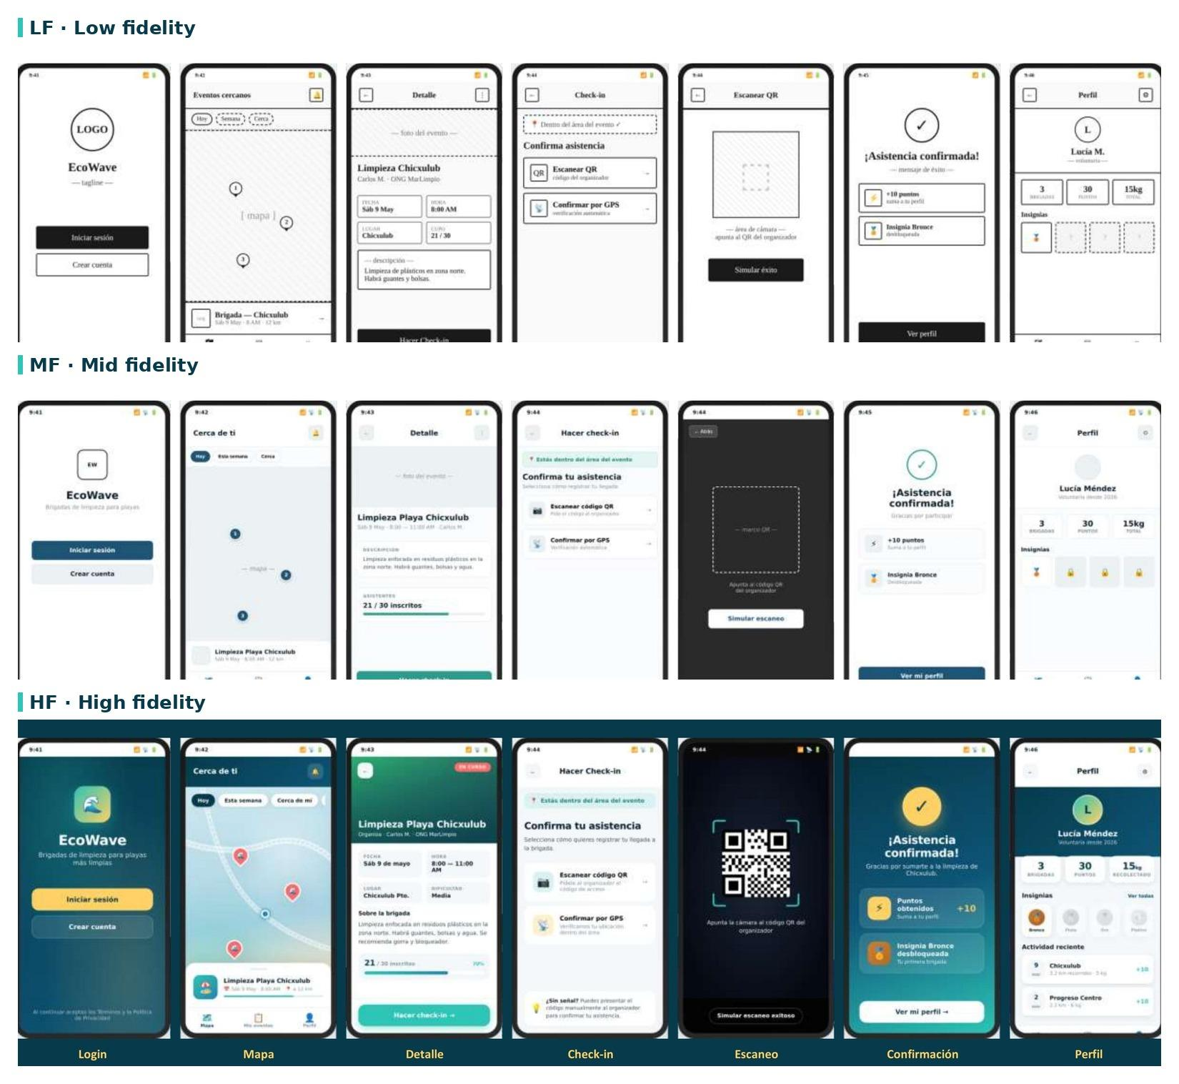
Fig. 2. Prototype evolution across three fidelity levels for the UC-002 flow (seven screens: Login → Map → Detail → Check-in → QR Scan → Confirmation → Profile). LF prioritizes structure without aesthetics; MF resolves hierarchy over a neutral palette; HF applies brand palette, microinteractions, and complete states.
E. Heuristic evaluation
Three team members applied Nielsen's ten heuristics [2] on the high-fidelity prototype independently. Each evaluator traversed the UC-002 flow twice (the first for familiarization, the second for inspection) and recorded their findings on a structured sheet with columns: heuristic violated, severity (Nielsen scale 0–4), evidence, and recommendation. Subsequently, the team consolidated findings in a joint session, removed duplicates, and assigned severity by consensus.
F. KLM design analysis
The Keystroke-Level Model [3] was applied to UC-002 to predict, before the user test, the time of an expert user without errors. The procedure was: (i) walk through the flow on the HTML prototype, (ii) decompose each step into atomic operators (M = mental act 1.20 s, P = tap 1.10 s, H = repositioning 0.40 s, R = system response, variable), (iii) apply Card et al.'s M-rules to insert mental acts before each non-anticipated action, and (iv) sum the standard durations. The two UC-002 routes (QR and GPS) were modeled for comparison.
G. User test design
Following Dumas and Redish [5], a controlled test was designed with six participants (four casual volunteers and two organizers) recruited externally to the team. The 40-minute session was structured in seven blocks: welcome and consent, pre-test questionnaire, brief training with think aloud explanation, task execution (app opening → confirmed check-in), post-test questionnaire (SUS [4] + Single Ease Question, SEQ), brief interview, and closing.
The environment was controlled to reproduce real conditions: a high-intensity LED lamp (≥ 10,000 lux) simulated direct sunlight on the device screen. One of the six sessions was additionally carried out with the device in limited 3G mode to verify behavior under reduced connectivity (NFR-02). The observer, distinct from the facilitator, recorded task time, number of interactions, number of errors, help requests, verbal comments, and feedback latency (measured in frame-by-frame review of the recording).
H. Acceptability levels
Two compliance bands were defined a priori for each metric (Table I) in order to avoid retrospective interpretation of the results.
TABLE I. ACCEPTABILITY LEVELS DEFINED A PRIORI
Metric | Acceptable | Satisfactory
Success rate | ≥ 80% | ≥ 95%
Total time | ≤ 45 s | ≤ 30 s
Errors per part. | ≤ 2 | ≤ 1
Interactions | ≤ 4 | ≤ 3
Visual latency | ≤ 800 ms | ≤ 500 ms
SUS | ≥ 68 | ≥ 80
IV. RESULTS
Results are reported grouped into three blocks corresponding to the three evaluation methods applied.
A. Heuristic evaluation
The inspection identified nine consolidated findings (Table II): three of major severity (3), four minor (2), and two cosmetic (1). The three major findings were incorporated into the high-fidelity prototype before the user test:
• H-01 (visibility of state during QR scan): a continuous animated scan line and the message "Point the camera…" were added.
• H-06 (error prevention when outside the event area): the indicator "You are inside the event area ✓" was added before presenting check-in options.
• H-09 (error recovery on scan failure): the block "No signal? Ask the organizer for the code manually" was added.
TABLE II. SUMMARY OF HEURISTIC FINDINGS BY SEVERITY
Severity | Total | Resolved | Pending
Major (3) | 3 | 3 | 0
Minor (2) | 4 | 1 | 3
Cosmetic (1) | 2 | 1 | 1
Total | 9 | 5 | 4
The four pending findings are all of minor or cosmetic severity and have been documented as actions for iteration 2.
B. KLM analysis
The KLM model applied to the UC-002 QR route predicted a total time of 12.0 s, broken down into 5 mental acts (6.00 s), 3 taps (3.30 s), 1 repositioning (0.40 s), and 2.30 s of system time. The GPS route turned out 2.1 s faster (9.9 s) but remained secondary because the ethnographic study indicated that organizers prefer QR to reduce false positives.
Against the NFR-05 threshold of 30 s, the KLM predicted a headroom of 18.0 s for the QR route and 20.1 s for GPS, sufficient to absorb the expected variability in real users (typically 30–50% above KLM due to learning and errors). The analysis also confirmed compliance with NFR-04 (3 effective taps) and NFR-06 (feedback of 300–500 ms in all modeled interactions).
C. User test
The six sessions were conducted between May 10 and May 17, 2026. Per-participant results are presented in Table III; time and SUS distributions are shown in Fig. 3 and Fig. 4.
TABLE III. RESULTS PER PARTICIPANT (UC-002)
ID | Profile | Time (s) | Err. | Taps | Success | SUS | SEQ
P1 | Volunteer, 22 | 17.3 | 0 | 3 | unaided | 82 | 6
P2 | Volunteer, 28 | 15.5 | 0 | 3 | unaided | 89 | 7
P3 | Volunteer, 34 | 24.0 | 2 | 5 | with help | 67 | 5
P4 | Volunteer, 19 | 15.3 | 0 | 3 | unaided | 87 | 7
P5 | Organizer, 41 | 21.0 | 1 | 4 | unaided | 81 | 7
P6 | Organizer, 32 | 16.6 | 0 | 3 | unaided | 91 | 7
 | Mean | 18.3 | 0.5 | 3.5 | — | 82.8 | 6.5
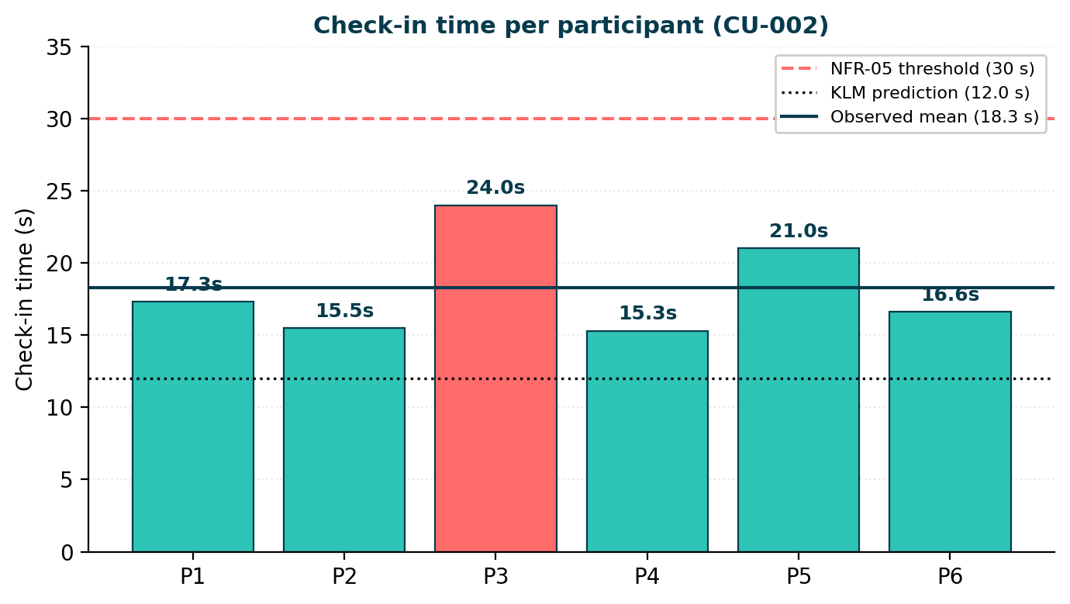
Fig. 3. Check-in time per participant. The dashed red line indicates the NFR-05 threshold (30 s); the dotted black line, the KLM prediction (12.0 s); the solid blue line, the observed mean (18.3 s). The only case above the mean was P3, associated with reading difficulty under the LED lamp.
Effectiveness. 100% of participants completed the task. Five out of six (83%) did so unaided; participant P3 required a verbal prompt from the facilitator to locate the "Check in" button, a fact documented as evidence of the pending heuristic finding H-02 (visibility of enrollment state).
Efficiency. The mean time was 18.3 s (median 17.0 s, σ = 3.5 s; range 15.3–24.0 s). This value represents a 52% increase over the KLM prediction (12.0 s), within the range expected in the literature (30–50%) and well below the NFR-05 threshold (30 s). Five of six participants (83%) additionally met the satisfactory level of Table I (≤ 30 s); the sixth case, P3, also met it at 24.0 s.
Interactions. The mean number of interactions was 3.5 (median 3); four participants completed with exactly 3 taps (meeting the satisfactory level of NFR-04), one with 4 and one with 5. Additional taps were concentrated in P3 and P5, both belonging to the group with lower self-reported technical experience.
Visual feedback. The mean latency measured frame-by-frame was 334 ms (range 291–429 ms), well within the NFR-06 threshold of 500 ms.
Satisfaction. The mean SUS of 82.8 corresponds to an excellent level according to the Bangor et al. bands (Fig. 4). Four of six participants exceeded 80; the atypical case of P3 (67) is associated with the reported difficulty of reading under the LED lamp. The mean SEQ was 6.5 out of 7, consistent with the SUS reading.
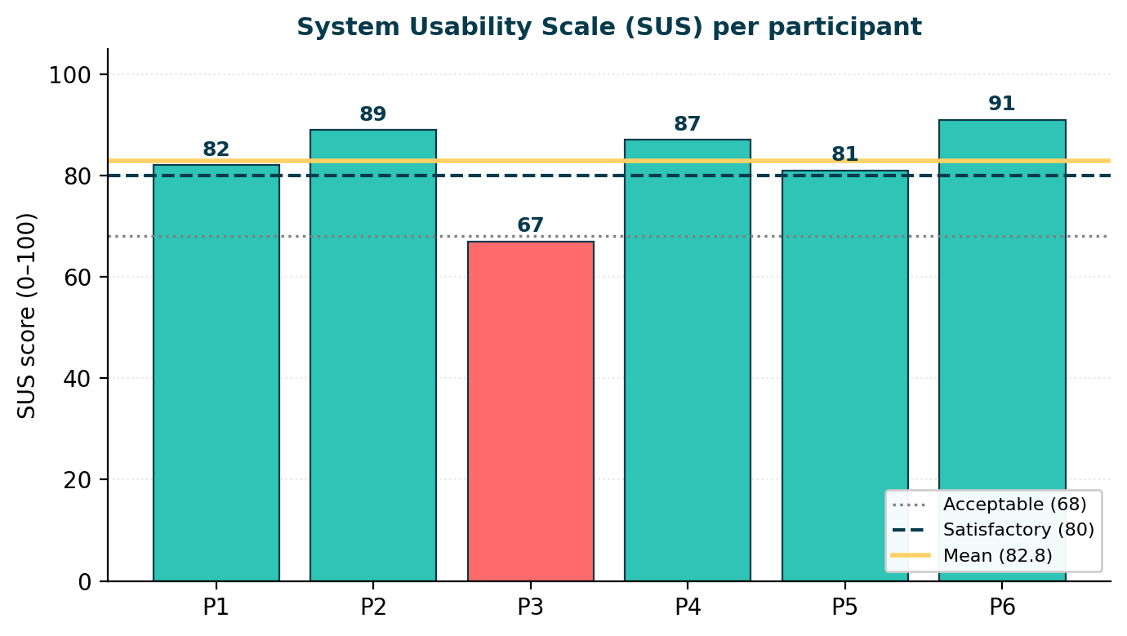
Fig. 4. Individual scores on the System Usability Scale. The mean of 82.8 exceeds the satisfactory threshold (80) and falls in the excellent band. P3 represents the atypical case linked to the simulated sunlight condition.
D. Qualitative findings
Post-task interviews identified two consistent patterns that had not been anticipated in the prior heuristic evaluation:
• Screen reflections under the LED lamp. Four of six participants tilted or partially covered the screen during the QR scan. The scan screen, with a black background, mitigated the problem; however, the detail screen (light background) received comments such as "I could barely see the gray time text". This suggests reinforcing the contrast of secondary information (NFR-07) in a future iteration.
• Transient confusion when switching from light to dark background (check-in screen → scan screen). Two participants blinked and re-oriented themselves; one commented "I thought it had turned off". This finding matches H-05 from the heuristic evaluation (cosmetic severity 1, pending).
No participant reported difficulty with the gamification; five of six expressed interest in the unlocked badge upon seeing the confirmation screen, and two spontaneously asked "how do I unlock the next one?", suggesting that the design fulfills its motivational function [8].
V. CONCLUSIONS
The complete User-Centered Design process applied to EcoWave yields five conclusions that articulate the contribution of this work:
1) Integral compliance with requirements. The critical flow UC-002 meets the four associated quantitative NFRs (NFR-04, NFR-05, NFR-06, and NFR-07) both in the KLM prediction and in the user test. The 39% headroom between the observed time (18.3 s) and the NFR-05 threshold (30 s) offers sufficient margin to absorb degradation a novice user may introduce in real beach conditions.
2) Coherence between predictive and empirical methods. KLM predicted 12.0 s and the user test observed 18.3 s, a 52% difference consistent with the literature for novice users. The convergence between both methods reinforces the validity of each and demonstrates that investing in KLM before the user test was a methodological success: it allowed structural problems to be discarded at low cost.
3) Iteration as a quality driver. Five of the nine heuristic findings were resolved before the user test, including the three of greatest severity. Without this iteration, the user test would have lost valuable information by being consumed in structural problems instead of identifying fine-grained issues.
4) Identification of the next iteration. The only finding that the user test added to the heuristic inventory is the legibility of secondary information under direct sunlight, evidenced by participant P3 (67 SUS, 24.0 s). This will be the priority problem for iteration 2, along with the incorporation of the pending heuristic findings of minor severity.
5) Methodological contributions. The work documents the complete UCD cycle with reproducible artifacts (SRS with traceability matrix, prototypes at three levels with explicit design questions, KLM modeling with reasoned M-rules, test protocol with acceptability levels a priori). This set may serve as a reference for other university or citizen projects with similar constraints (outdoor use, variable connectivity, heterogeneous user profiles).
The resulting product validates that it is possible to design a critical mobile flow that simultaneously satisfies aggressive constraints of time, accessibility, and user satisfaction, in a domain (citizen environmental management) where these dimensions are rarely addressed at the same time. The next phase of the project consists of closing the pending findings and proceeding to the technical development of the application.
REFERENCES
[1] D. A. Norman, The Design of Everyday Things, Revised ed. New York, NY, USA: Basic Books, 2013.
[2] J. Nielsen, "10 Usability Heuristics for User Interface Design," Nielsen Norman Group, 1994. [Online]. Available: https://www.nngroup.com/articles/ten-usability-heuristics/
[3] S. K. Card, T. P. Moran, and A. Newell, "The keystroke-level model for user performance time with interactive systems," Communications of the ACM, vol. 23, no. 7, pp. 396–410, 1980.
[4] J. Brooke, "SUS: a 'quick and dirty' usability scale," in Usability Evaluation in Industry, P. W. Jordan et al., Eds. London, UK: Taylor & Francis, 1996, pp. 189–194.
[5] J. S. Dumas and J. C. Redish, A Practical Guide to Usability Testing, Revised ed. Portland, OR, USA: Intellect, 1999.
[6] J. Nielsen, "Why You Only Need to Test with 5 Users," Nielsen Norman Group, 2000. [Online]. Available: https://www.nngroup.com/articles/why-you-only-need-to-test-with-5-users/
[7] World Wide Web Consortium, Web Content Accessibility Guidelines (WCAG) 2.1, W3C Recommendation, June 2018. [Online]. Available: https://www.w3.org/TR/WCAG21/
[8] S. Deterding, D. Dixon, R. Khaled, and L. Nacke, "From game design elements to gamefulness: defining gamification," in Proceedings of the 15th International Academic MindTrek Conference, ACM, 2011, pp. 9–15.
[9] A. Bangor, P. Kortum, and J. Miller, "Determining what individual SUS scores mean: adding an adjective rating scale," Journal of Usability Studies, vol. 4, no. 3, pp. 114–123, 2009.
[10] M. Hassenzahl and N. Tractinsky, "User experience – a research agenda," Behaviour & Information Technology, vol. 25, no. 2, pp. 91–97, 2006.
[11] P. Holleis, F. Otto, H. Hussmann, and A. Schmidt, "Keystroke-level model for advanced mobile phone interaction," in Proceedings of the SIGCHI Conference on Human Factors in Computing Systems, ACM, 2007, pp. 1505–1514.
[12] International Organization for Standardization, ISO 9241-210:2019. Ergonomics of human-system interaction — Part 210: Human-centred design for interactive systems, Geneva, Switzerland, 2019.

